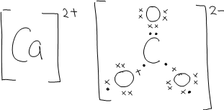
1 (a) (i)

(ii) CaCO₃(s)→CaO(s) + CO₂(g)

- Decomposition temperature of barium carbonate would be higher than calcium carbonate.

Ba²⁺ ion has a larger ionic radius and lower charge density than Ca²⁺ ion,
thus it has lower polarising power. Carbonate ion in barium carbonate is less polarised and thus barium carbonate is more stable.

(b) (i) Removal of liquid reactant increase orderliness of the system, thus the
entropy is negative..

(ii) Standard enthalpy change of formation of CaO is the enthalpy change (or heat evolved) when one mole of CaO is formed from calcium and oxygen under standard conditions (298K, 1 atm).

(iii) ΔH^{θ}_{r} = ∑ΔH^{θ}_{f} (products) − ∑ΔH^{θ}_{f} (reactants)
= (−986.1) − [(−241.5) + (−638.2)]
= −106.4 kJ mol⁻¹ (or −106 kJ mol⁻¹)

ΔG^{θ} = ΔH^{θ} - TΔS^{θ}
= (−106.4 x 1000) − [(273+25) x -26] J mol⁻¹
= −98.7 kJ mol⁻¹

Since ΔGº < 0, the reaction is spontaneous at 25 ºC.

(iv) Amount of CaO = 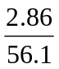 = 0.0510 mol
Heat evolved = 0.0510 x 106.4 = 5.43 kJ (or 5.3 kJ)
Temperature change = 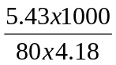 = 16.2 °C (or 15.8 ºC)
Final temperature = 25 + 16.2 = 41.2 °C (or 40.8 ºC)

(c) (i) BaSO₄(s) Ba²⁺(aq) + SO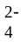(aq)
x mol dm⁻³ x mol dm⁻³
K_{sp} = [Ba²⁺] [SO]
1.08 x 10⁻⁹ = x²
x = 3.29 x 10⁻⁵ mol dm⁻³

Solubility of barium sulfate in water = 3.29 x 10⁻⁵ mol dm⁻³
(ii) pOH = 14-12.3
= 1.7
[OH⁻] = 0.0200 mol dm⁻³

K_{sp} = [Ba²⁺] [OH–]²
9.80 x 10⁻⁵ = [Ba²⁺] (0.0200) ²
[Ba²⁺] = 0.245 mol dm⁻³

K_{sp} = [Ba²⁺] [SO₄^{2–}]
1.08 x 10⁻⁹ = (0.245) [SO₄^{2–}]
[SO₄^{2–}] = 4.41 x 10⁻⁹ mol dm⁻³

Solubility of barium sulfate in FA1 solution = 4.41 x 10⁻⁹ mol dm⁻³

(iii) BaSO₄ is less soluble in FA1 solution than in water because the presence of Ba²⁺ ions in solution FA1 due to dissolved Ba(OH)₂ suppresses the solubility of BaSO₄ by common ion effect.

(iv) [Ba²⁺] in mixture = 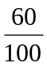 x 3.0 x 10⁻³ = 1.80 x 10⁻³ mol dm⁻³

[SO₄^{2–}] in mixture = 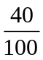 x 2.5 x 10⁻³ = 1.00 x 10⁻³ mol dm⁻³

[Ba²⁺] [SO₄^{2–}]= (1.80 x 10⁻³) (1.00 x 10⁻³)
= 1.80 x 10⁻⁶ mol² dm⁻⁶ > K_{sp} of BaSO₄
Hence, precipitate of BaSO₄ will form.

2(a) (i) Zn(s)|Zn²⁺⁽aq)||Cu²⁺⁽aq)|Cu(s)

(ii) 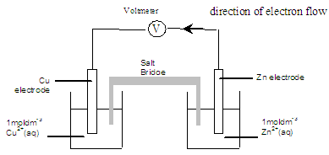

Eº_{cell} = 0.34 – (-0.76) = +1.10 V
` (iii) Zn half-cell: Zn(s) Zn²⁺(aq) + 2e`
Cu half-cell: Cu²⁺(aq) + 2e Cu(s)

Overall equation: Zn(s) + Cu²⁺(aq) Cu(s) + Zn²⁺(aq)

(b) (i) Standard cell potential is the potential difference between two half-cells
at standard conditions or 1 mol dm⁻³ concentration, 1 atm pressure and 298 K

(ii) T = 298 K
n = 2 moles

(iii) ln K = 2 x 9.65 x 10⁴ x 1.10 / (8.31 x 298)
K = 1.71 x 10³⁷

(iv) The value is very large,
hence this reaction is expected to go to completion
(or the equilibrium lies far to the right)
(or there is a significant amount of products compared to reactants)

(c) The scientist would see a deep blue solution
of [Cu(NH₃)₄(H₂O)₂]²⁺ or [Cu(NH₃)₄]²⁺ or copper(II) tetraammine complex

[Cu(H₂O)₆]²⁺ + 4NH₃ [Cu(NH₃)₄(H₂O)₂]²⁺ + 4H₂O

(d) (i) Cu²⁺ (aq) + 2e Cu(s)

The concentration of Cu²⁺(aq) falls, due to the formation of the copper complex. By Le Chatelier’s Principle, the above equilibrium will then shift to the left,

and the electrode potential of the copper half-cell will become less positive (decreases).

(ii) Since Eº_{cell} = Eº_{reduction} – Eº_{oxidation}
and the copper half-cell is the reduction half-cell.

A less positive (or decrease in) Eº_{reduction} will result in a less positive (or decrease in) Eº_{cell}.

(e) According to the Nernst equation, K is related to Eº_{cell}.
Thus, upon adding ammonia, we cannot use the Nernst equation as addition of ammonia causes the cell to be non-standard.

3(a) (i) Reaction I has a higher E_{a} than reaction II.

This is because reaction I involves the breaking of the C – Br bond whereas

reaction II involves the attraction of opposite charges (or H⁺ + OH⁻ → H₂O)

(ii) The rate of the reaction between CH₃CH₂CH₂Cl(l) and NaOH(aq) would be slower because C – Cl bond is stronger than C – Br bond.

(b) (i) rate = k[CH₃CH₂CH₂Br] [NaOH] OR rate = k[CH₃CH₂CH₂Br]² OR rate = k[NaOH]²
(ii) On dilution, the rate will decrease by four times
or rate will be reduced to ¼ of the original rate.

(c)(i) Amount of Z = Amount of NaOH
= 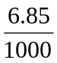 X 0.100
= 6.85 x 10⁻⁴ mol

1.00 X 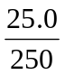
M_{r} of Z = 6.85 x 10⁻⁴
= 146

(ii) X has no reaction with Na metal shows that it is not an alcohol, a carboxylic acid or
phenol.
.
X has no reaction with Fehling’s solution shows that it is not an aliphatic aldehyde.

X gives an orange precipitate with 2,4-dinitrophenylhydrazine reagent shows that it is a ketone.

X gives a pale yellow precipitate with warm, alkaline aqueous iodine shows that it contains the group CH₃C=O.
I

X is chiral means that it contains a carbon atom with four different groups or atoms attached to it.

* * *
CH₃CH₂CH(CH₃)CCH₃ X CH₃CH₂CH(CH₃)C(OH)(CN)CH₃ Y
II
O

* *
CH₃CH₂CH(CH₃)C(OH)(CO₂H)CH₃ Z

(iii) CH₃CH₂CH(CH₃)CCH₃ + HCN → CH₃CH₂CH(CH₃)C(OH)(CN)CH₃
II
O

CH₃CH₂CH(CH₃)C(OH)(CN)CH₃ + 2H₂O + H⁺ → CH₃CH₂CH(CH₃)C(OH)(CO₂H)CH₃ + NH₄⁺

4 (a) (i) An acid is defined as a proton donor.

H₂PO₄⁻ + H₂O HPO₄²⁻ + H₃O⁺

(ii) Ka = 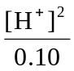 = 6.2 x 10⁻⁸

[H⁺] =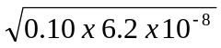
= 0.787 x 10⁻⁴ mol dm⁻³

pH = - lg ( 0.787 x 10⁻⁴)
= 4.10

(b) (i) Buffer solution is a solution that is capable of resisting pH changes when a
small amount of (strong) acid or (strong) base is added.

(ii) From the given information; H₂PO₄⁻ is half-neutralised.
Hence, [ H₂PO₄⁻ ] = [ HPO₄²⁻ ]
weak acid = conjugate base

pH = pKa = -lg 6.2 x 10⁻⁸
= 7.21

(iii) When a small amount of strong acid is added such as HCl(aq),
the amount of H⁺ added is removed by the conjugate base , HPO₄²⁻
H⁺ (aq) + HPO₄²⁻ (aq) H₂PO₄⁻(aq)

When a small amount of strong base is added such as NaOH(aq),
the amount of OH⁻ added is removed by the weak acid, H₂PO₄⁻

OH⁻ (aq) + H₂PO₄⁻ (aq) HPO₄²⁻ (aq) + H₂O(l)

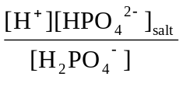
(iv) pH = pKa + lg 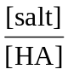 or K_{a} =
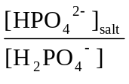

= 6.2 x 10⁻⁸ / 10^{−7.4} = 1.56

H₂N
C
IIO
H
C
COOH
I
CH₂
COOH
C
H
CH₂
N
I
H
(c) (i) asp-phe

(ii) amide or peptide functional group

(iii) Asp is an acidic amino acid as the R-group contains an additional –COOH group.
Hence, carbonate can be decomposed and effervescence occurs for asp but not phe when Na₂CO₃ solution is added

(d) For asp R-group interaction : hydrogen bonding and ionic bonding
phe R--group interaction : van der Waals’ attraction

(e) Aspartame is made up of naturally occurring amino acids which are stable molecules
at room temperature.

5(a) (i) Chlorine is used in water purification to kill bacteria or disinfect water due to
its strong and effective oxidising property

Cl₂ + 2e⁻ 2Cl⁻ Eº = +1.36 V
Br₂ + 2e⁻ 2Br⁻ Eº = +1.07 V

Bromine is not used because it is a weaker oxidising agent than chlorine as can be seen by its less positive Eº value.

(ii) 2OH⁻ + Cl₂ Cl⁻ + ClO⁻ + H₂O

OR

2NaOH + Cl₂ NaCl + NaClO + H₂O

Chlorine undergoes disproportionation.

(b) (i) Cl₂ + 2Fe²⁺ → 2Cl⁻ + 2Fe³⁺
Eº_{cell} = +1.36 + (– 0.77) = +0.59 V (feasible)

(ii)
 | Na | H | I | O
Mass/ g | 16.9 | 1.1 | 46.7 | 35.3
No. of moles | 0.73 | 1.10 | 0.37 | 2.21
Simplest ratio | 2 | 3 | 1 | 6

Empirical formula of X is Na₂H₃IO₆
7Cl₂ + I₂ + 18NaOH → 2Na₂H₃IO₆ + 14NaCl + 6H₂O
Oxidation number of iodine in X is +7.

(c) (i)
Displayed formula | Type of reaction
A: 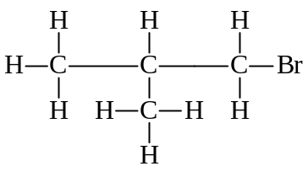 | A undergoes nucleophilic substitution to form  2-methylpropan-1-ol
B: 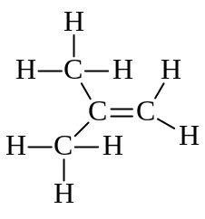 | A undergoes elimination to form an alkene, B
C: 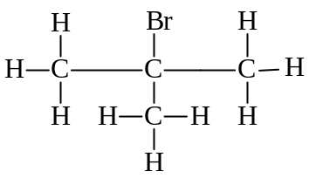 | B undergoes electrophilic addition to form C.
D: 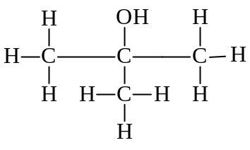 | C undergoes nucleophilic substitution to form an alcohol, D.

(ii) Reagent and condition: Hot acidified potassium dichromate(VI) solution

Compound | Observation
2-methylpropan-1-ol | Orange solution turns green
D | Orange solution remains unchanged

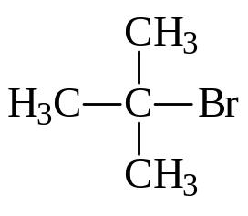
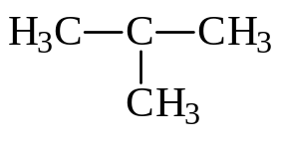
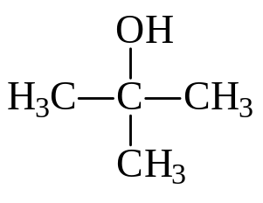
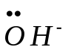
(iii)
slow
fast
+
+
+ Br –
δ+
δ–

